4
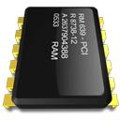

ECU : Honda Accord 2.4 2008

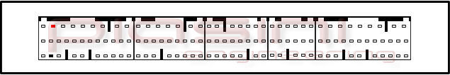

Connect as below:

Serial Suite: ECU Plug:

Red to 1 Pins Red (Power Supply +12 Volt)
Black to 1 Pins Black (Ground)

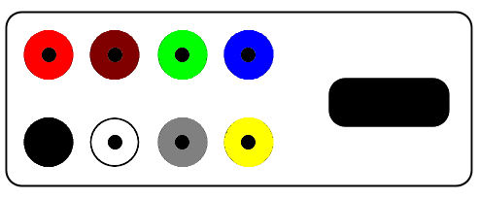

Piasiniengineering info@piasinienginnering.it – http://www.piasiniengineering.it
Tel: +39 0342 489060 - Fax: +39 0342 488298

Where to connect the flat cable:

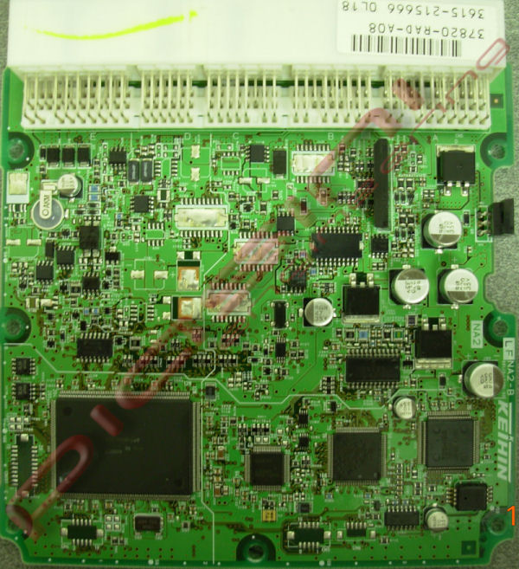

This is where you have to connect the flat cable.

Piasiniengineering info@piasinienginnering.it – http://www.piasiniengineering.it
Tel: +39 0342 489060 - Fax: +39 0342 488298

READ the ECU:

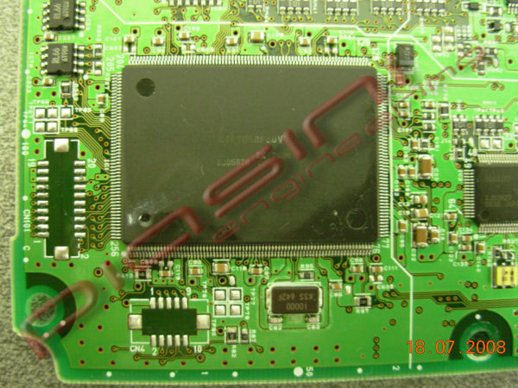

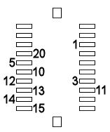

Connect the flat cable following the number like in the picture.
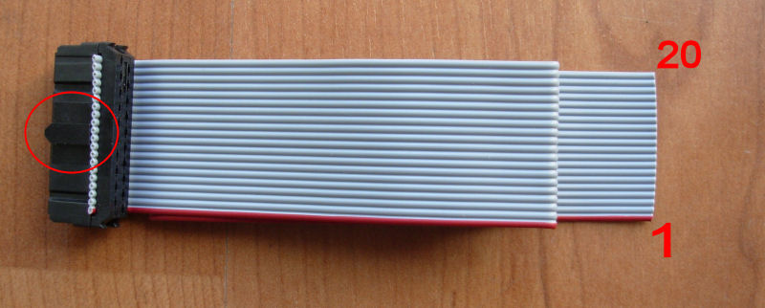

Piasiniengineering info@piasinienginnering.it – http://www.piasiniengineering.it
Tel: +39 0342 489060 - Fax: +39 0342 488298
WRITE the ECU:
Back side:
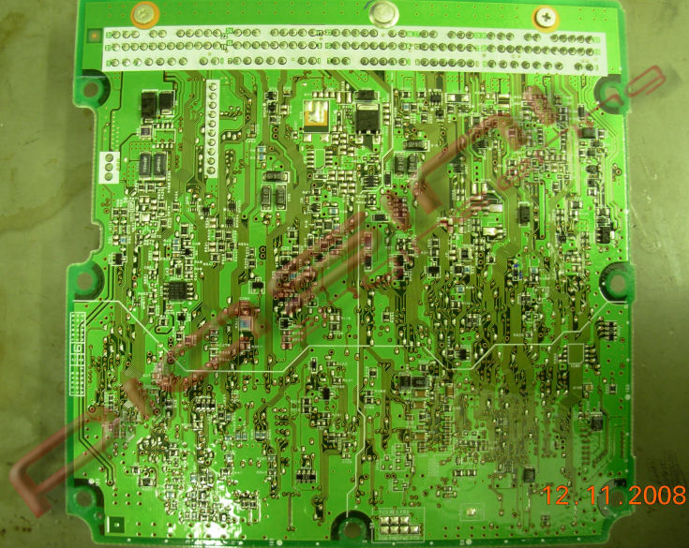

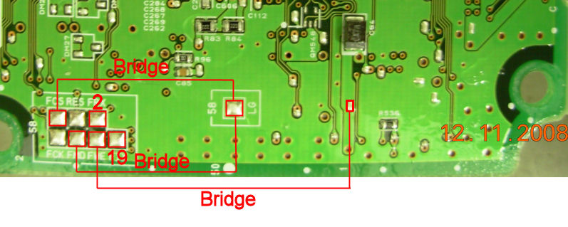

For write the ECU put 3 wire(Bridge) like in the picture and connect other 2 wire (2,19) of the flat cable, the other wire of flat cable is still connect in the other side of ecu.

Piasiniengineering info@piasinienginnering.it – http://www.piasiniengineering.it
Tel: +39 0342 489060 - Fax: +39 0342 488298

